EXPERIMENT NO: 4

Name: Yash Liladhar Amarapurkar

Roll No: A41

Input:

import java.awt.\*;

import java.awt.event.ActionEvent;

import java.awt.event.ActionListener;

class Listenerdemo extends Frame implements ActionListener

{ TextField t1,t2,t3;

Button bt;

Listenerdemo()

{

setSize(500,500);

setVisible(true);

t1=new TextField(15);

t1.setBounds(20,100,80,30);

t2=new TextField(15);

t2.setBounds(20,150,80,30);

t3=new TextField(15);

t3.setBounds(20,200,80,30);

bt=new Button("add");

bt.setBounds(20,260,80,30);

add(t1);

add(t2);

add(t3);

add(bt);

bt.addActionListener(this);

}

public void actionPerformed(ActionEvent ae )

{

int a=Integer.parseInt(t1.getText());

int b=Integer.parseInt(t2.getText());

int c=a+b;

t3.setText(" "+c);

}

public static void main(String[] args)

{

new Listenerdemo();

}

}

Output:

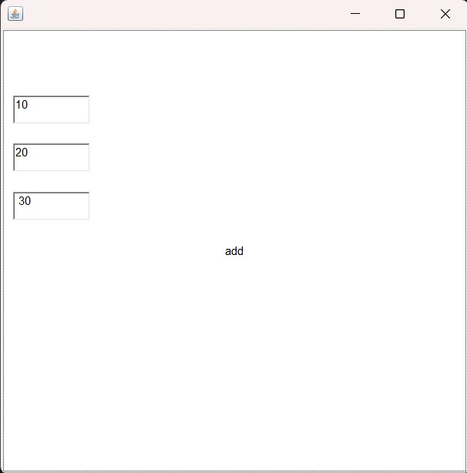

Input:

import java.awt.\*;

import java.awt.event.MouseEvent;

import java.awt.event.MouseListener;

public class mouse1 extends Frame implements MouseListener

{

mouse1()

{

setSize(500,500);

setVisible(true);

addMouseListener(this);

}

public void mouseClicked(MouseEvent ae)

{

this.setBackground(Color.RED);

}

public void mousePressed(MouseEvent e){

this.setBackground(Color.BLACK);

}

public void mouseReleased(MouseEvent e)

{

this.setBackground(Color.CYAN);

}

public void mouseEntered(MouseEvent e){

this.setBackground(Color.MAGENTA);

}

public void mouseExited(MouseEvent e){

this.setBackground(Color.GREEN);

}

public static void main(String[] args)

{

new mouse1();

}

}

Output:

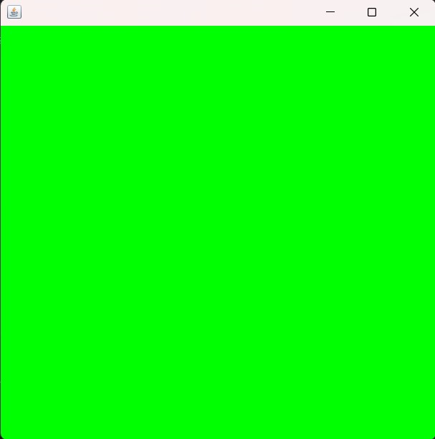

Input:

import java.awt.\*;

import java.awt.event.KeyEvent;

import java.awt.event.KeyListener;

public class Key1 extends Frame implements KeyListener

{

Label l1;

TextField t1,t2;

Key1()

{

setSize(500,500);

setVisible(true);

t1=new TextField(15);

t1.setBounds(20,100,80,30);

add(t1);

l1 = new Label();

l1.setBounds(80,200,80,30);

add(l1);

t1.addKeyListener(this);

}

public void keyPressed(KeyEvent e)

{

//System.out.println("key pressed"); this for cmd

l1.setText("Key is pressed");

}

public void keyReleased(KeyEvent e)

{

//System.out.println("key is released"); this for cmd

l1.setText("Key is Released");

}

public void keyTyped(KeyEvent e)

{

// System.out.println("key is typed"); this for cmd

l1.setText("Key is Typed");

}

public static void main(String[] args)

{

new Key1();

}

}

Output:

